Experiment worksheet

2.1 Mixtures are a combination of two or more substances

Pages 30–31 and 174

Challenge 2.1: Comparing different types of mixtures

A DIRTY WATER

What you need:

soil, water, jar with screw-top lid

What to do:

1 Put some soil and water in the jar to create a watery mixture.

2 Screw the lid on tightly, then shake the jar.

• What happens to the soil particles?

• Does anything float on the water?

• How can you explain the behaviour of this mixture?

• What type of mixture is dirty water?

B MAKING A FOAM

**SAFETY:** CHECK FOR EGG OR DAIRY ALLERGIES.

What you need:

cream or egg white, hand or electric whisk, large metal bowl

What to do:

1 Whip the cream or egg white until it increases significantly in size and holds its shape.

• Explain why the foam you have created is classified as a colloid.

C MIXING OLIVE OIL AND WATER

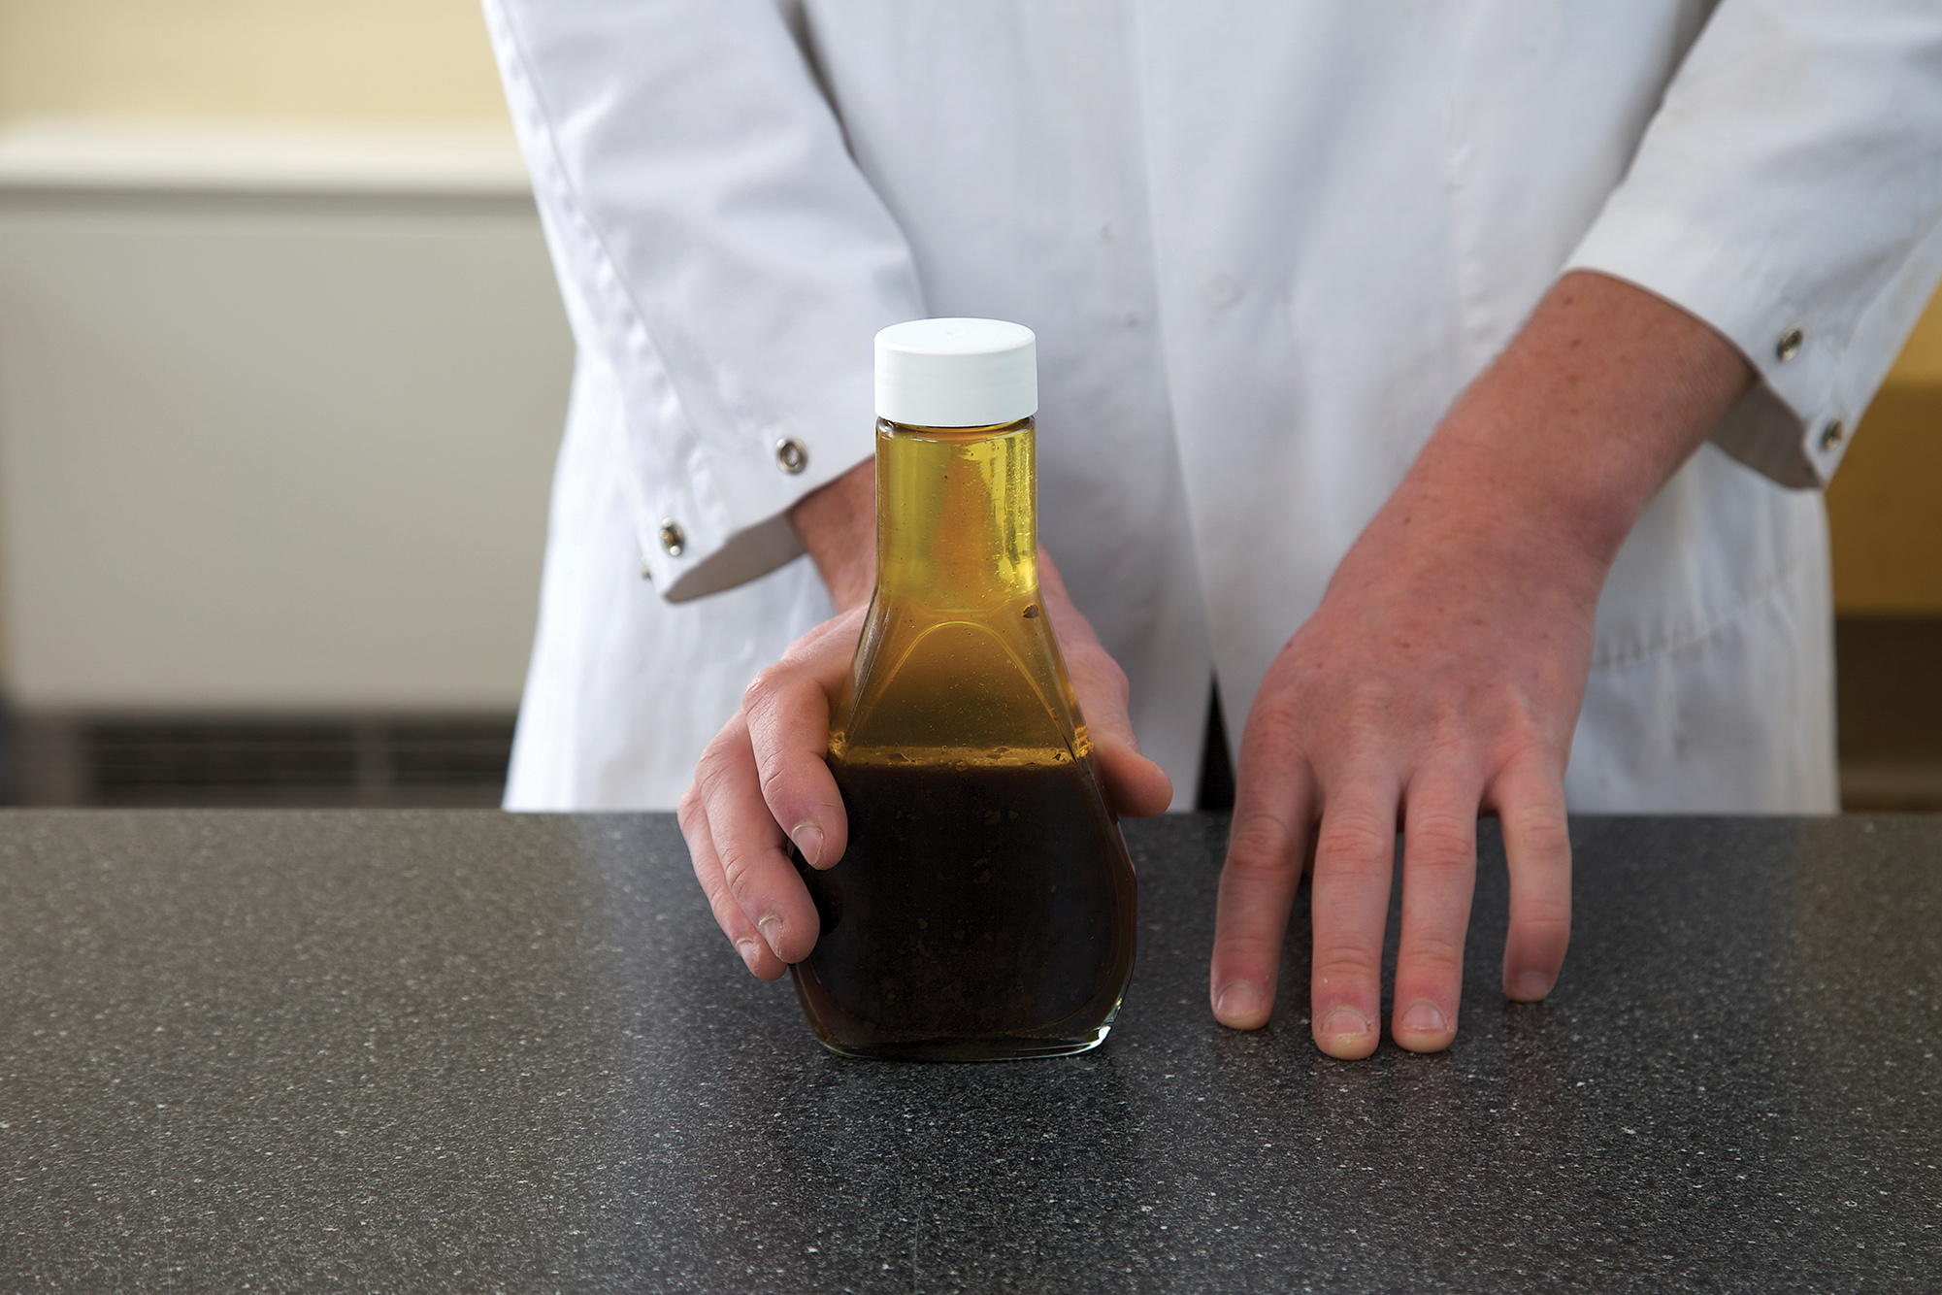

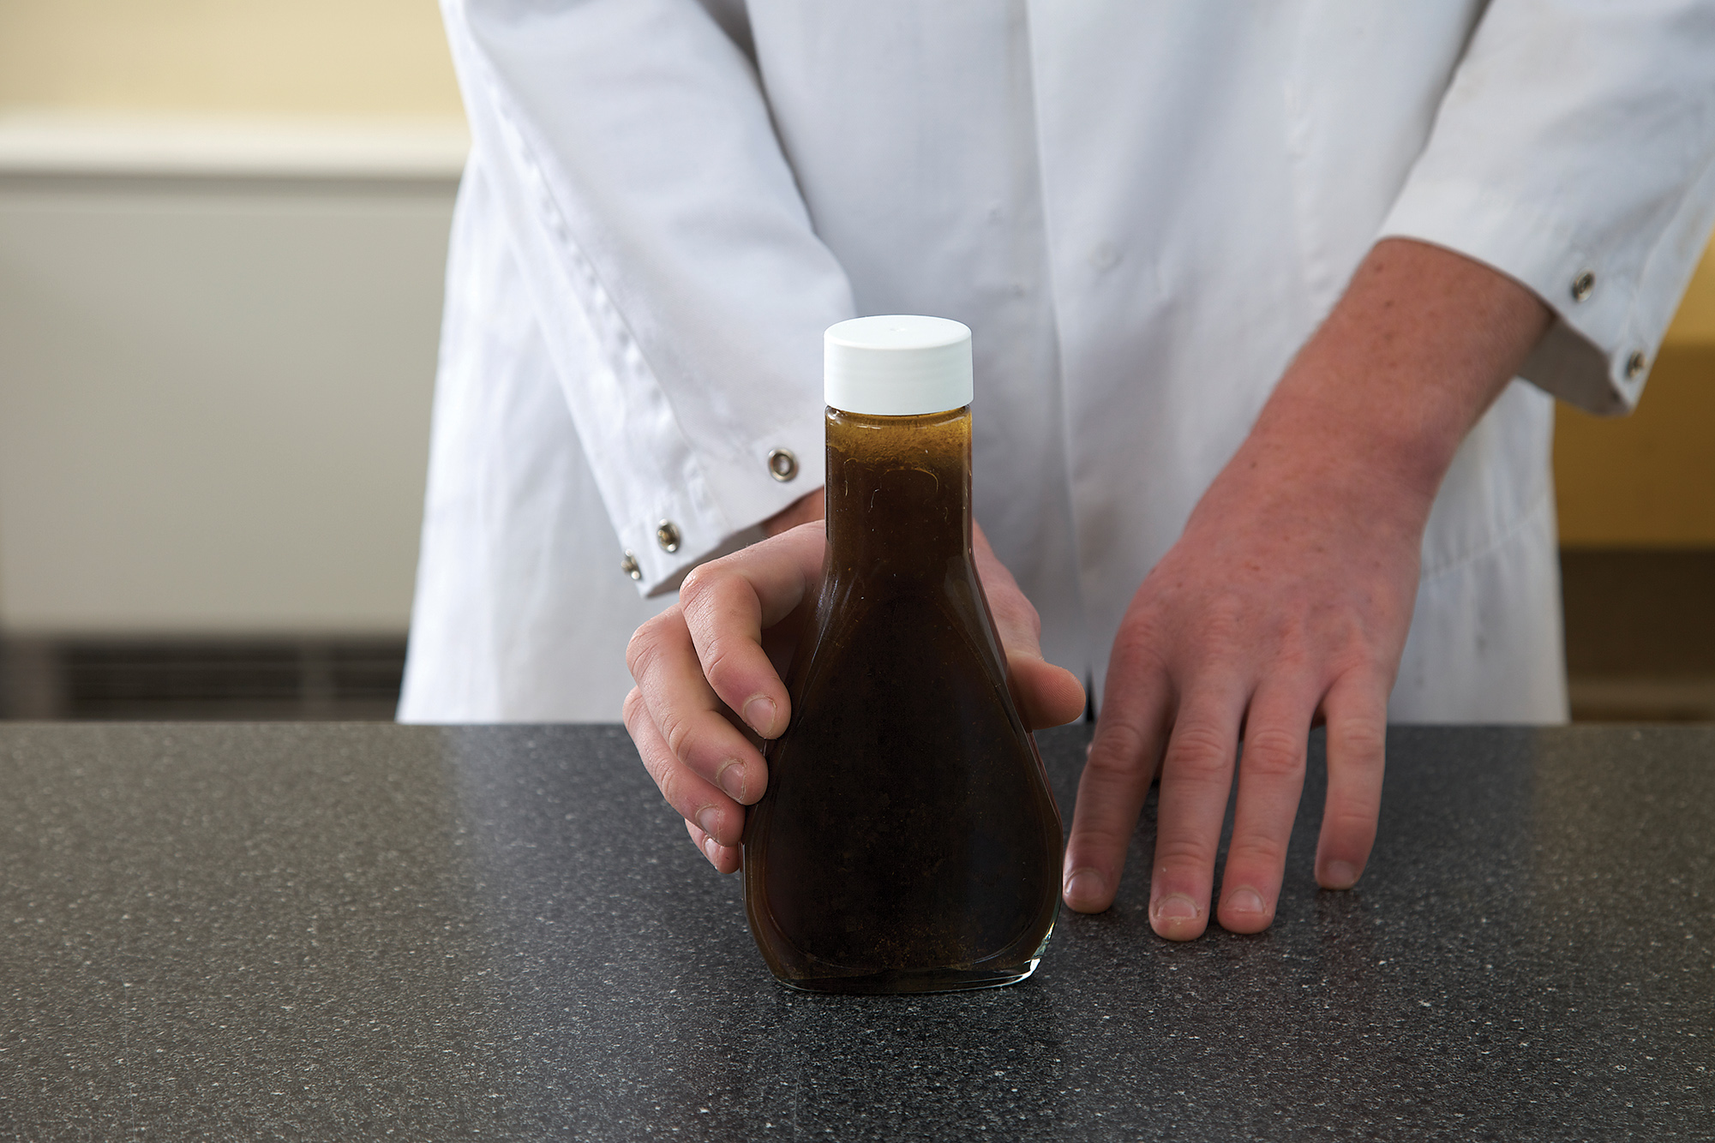

**Figure 1** Salad dressing (top) before and (bottom) after adding an emulsifier.

What you need:

olive oil, water, jar with screw-top lid, detergent

What to do:

1 Two-thirds fill a jar with equal parts of water and oil. Observe what happens.

2 Screw the lid on the jar tightly and shake the mixture vigorously. Observe what happens immediately and over time.

3 Add a couple of drops of detergent to the mixture and shake the jar again.

• How does the mixture change when you add the detergent?

• Explain what is happening using the terms ‘colloid’, ‘mixture’, ‘emulsion’ and ‘emulsifier’.

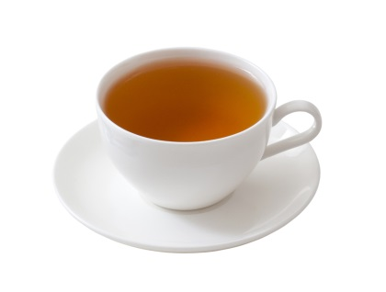D ADDING SUGAR TO WATER

What you need:

water, table sugar, teaspoon, beaker of glass

What to do:

1 Add a small amount of sugar to water in a glass and stir.

• Describe what has happened to the sugar.

E MAKING PERFUME: ANOTHER SOLUTION

What you need:

lavender flowers, methylated spirits, scissors, jar with a lid

What to do:

1 Cut the lavender flowers into tiny pieces and place them in the jar.

2 Cover the lavender flowers with methylated spirits.

3 Seal the jar and leave overnight.

4 The following day, dip your finger in the methylated spirits and dab it on a piece of paper or your wrist.

5 Allow the methylated spirits to evaporate, then smell.

• Why is this mixture considered to be a solution? Identify the solute and the solvent.

• Would this experiment work if you put the lavender flowers in a jar of water?

• Why is it handy that the methylated spirits evaporate easily?

Experiment worksheet

2.2 A solution is a solute dissolved in a solvent

Pages 32–33 and 175

Experiment 2.2A: What if salt were dissolved in water

Aim

To investigate whether a mixture of salt and water forms a solution.

Materials

• Test tubes

• Test tube rack

• Spatula

• Salt

Method

1 Add 5 cm of water to a test tube.

2 Add 1 spatula of salt to the test tube. Carefully stir the mixture.

3 Does the mixture form a solution? Record your results.

Inquiry: What if other substances are mixed with water?

**Powders to test:** copper carbonate, bath salts, talcum powder, brown sugar, flour

• What (independent variable) are you changing from the method above?

• Name three variables you will need to keep the same as in the method above.

• How will you know if your new powder forms a solution with water?

• Predict which powders will form a solution.

• What equipment will you need to complete this experiment?

• Write down the method you will use to complete your investigation.

• What sort of table will you need to draw to show your results?

(Show your teacher your planning for approval.)

Results

Complete your investigation, drawing and filling in your table of results in the space provided.

|  |
| --- |
|  |

Discussion

1 How many substances were soluble in water? List them.

2 Of the substances that did not dissolve, did any form a suspension?

3 Which substances took the longest to dissolve? Why do you think this happened?

4 Were any of your results unexpected?

5 Name three other substances you know dissolve in water.

6 Do you think water is a good solvent? Give reasons based on the results of your experiment.

7 How would you change this experiment to find out more about dissolving substances?

Experiment worksheet

2.2 A solution is a solute dissolved in a solvent

Pages 32–33 and 176

Experiment 2.2B: What if the solvent were heated when making a mixture?

Many solutes dissolve only in certain solvents. Some dissolve very slowly and, when they do, only a certain amount of solute dissolves before the solution becomes saturated.

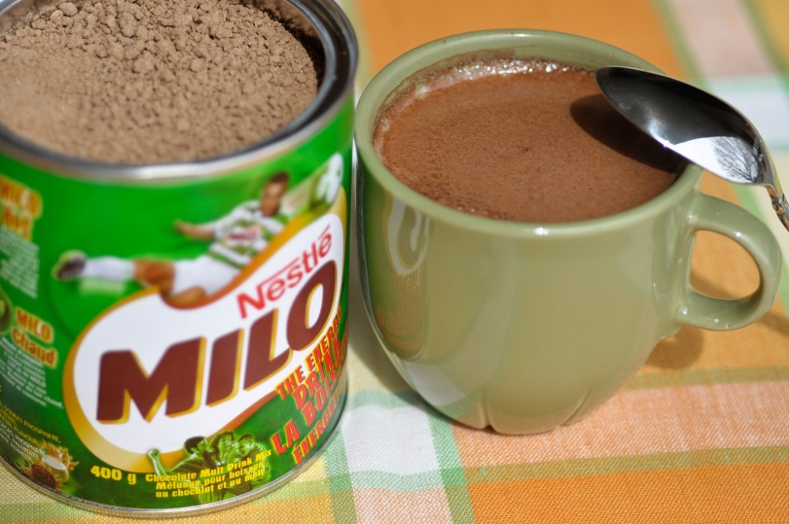Aim

To investigate ways to alter the rate (speed) at which a solute dissolves and/or the amount of solute that will dissolve.

Materials

• Milo

• Milk

• Teaspoon

• Small beaker

• Measuring cylinder

• Thermometer

• Hot plate to heat milk

Method

**SAFETY:** DO NOT EAT OR DRINK IN THE LABORATORY.

1 Measure out 50 mL milk and add it to the small beaker.

2 Carefully measure 1 teaspoon of Milo by smoothing the surface until it is even with the edges of the spoon.

3 Add the spoonful of Milo to the milk and stir until it dissolves.

4 Repeat steps 2 and 3 until the Milo no long dissolves.

5 How many spoonfuls of Milo dissolved in the milk?

Inquiry: What if the milk were heated?

1 What (independent) variable will you change from the first method?

2 What (dependent) variable will you measure and/or control?

3 Name three variables that you will keep the same as in the first method.

4 What equipment will you need to complete this experiment?

5 Predict how many spoonfuls of Milo will dissolve in warm milk.

6 Write down the method you will use to complete your investigation.

7 What sort of table will you need to draw up to show your results?

(Show your teacher your planning for approval.)

Results

Complete your investigation, drawing and filling in your table of results.

|  |
| --- |
|  |

Discussion

1 Describe how the amount of Milo that dissolved changed the second time.

2 What did you do differently to achieve this change?

3 What variables did you keep the same during the experiment?

4 Can you think of any situations in everyday life that would benefit from understanding the results of your investigation?

5 How would you change this experiment to find out more about dissolving substances?

Experiment worksheet

2.3 Mixtures can be separated according to their properties

Pages 34–35 and 178

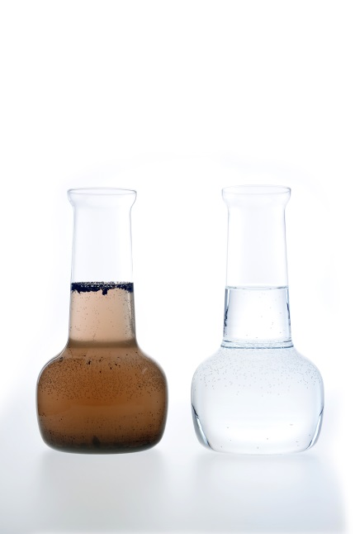Experiment 2.3: What if a flocculent were added to muddy water?

Aim

To investigate the effect of a flocculent.

Materials

• Muddy water (3 g dirt in 50 mL water)

• 2 jars

• 0.5 M sodium carbonate solution

• 0.5 M aluminium sulfate solution

• Test tubes

Method

1 Half-fill each jar with muddy water and label one A and the other B.

**SAFETY:** HANDLE THE ALUMINIUM SULFATE SOLUTION WITH CARE, WEAR EYE PROTECTION AND AVOID CONTACT WITH SKIN.

2 Add half a test tube of aluminium sulfate solution to jar A.

3 Slowly add half a test tube of sodium carbonate solution to jar B.

4 Leave both jars undisturbed for approximately 15 minutes.

5 Record your observations, comparing the water in jar A with that in jar B.

Inquiry: How much flocculent is needed to effectively separate a mixture of mud and water?

1 What amounts of the flocculent will you add to the muddy water mixture?

2 How will you measure if the muddy water is separated enough? (HINT: how much light should shine through the mixture?)

3 Name three variables you will keep the same as in the first method.

4 Write down the method you will use to complete your investigation.

5 What sort of table will you need to draw up to show your results?

(Show your teacher your planning for approval.)

Results

Complete your investigation, drawing and filling in your table of results in the space provided.

|  |
| --- |
|  |

Discussion

1 What effect did the aluminium sulfate solution have on the muddy water?

2 What effect did the sodium carbonate solution have on the muddy water?

3 Which of the two substances (aluminium sulfate or sodium carbonate) acted as a flocculent? Give evidence to support your answer.

4 Why might it be important for water treatment plants to minimise the amount of flocculent added to waste water?

Conclusion

What effect does a flocculent have on mixtures?

Experiment worksheet

2.3 Mixtures can be separated according to their properties

Pages 34–35 and 177

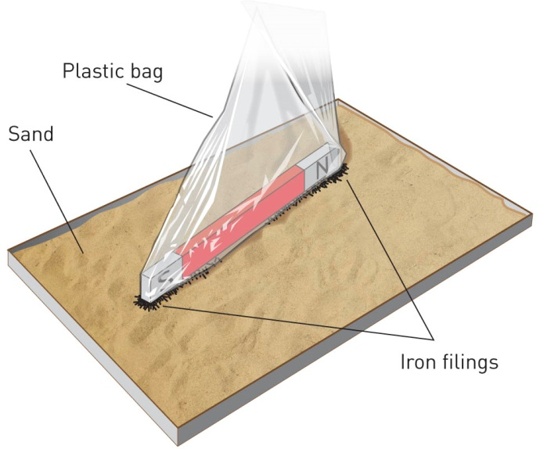Skills Lab 2.3A: Separation using magnetic properties

What you need:

mixture of iron filings and sand, magnet, plastic bag

What to do:

1 Place the magnet inside the plastic bag.

2 Pass the bagged magnet over the mixture so that the iron filings are attracted.

3 Turn the plastic bag inside out so that all the iron filings are trapped.

Questions

1 How effective do you think this method was at separating the iron filings from the sand?

2 Could you use this method for all metals? Explain.

Experiment worksheet

2.3 Mixtures can be separated according to their properties

Pages 34–35 and 177

Skills Lab 2.3B: Separating mixtures using sedimentation and flotation

What you need:

two mixtures (‘A’ contains sand and sawdust; ‘B’ contains sand and salt), water, spatula, stirring rod, two beakers

What to do:

1 Place at least three heaped spatulas of mixture A into a beaker.

2 Add water and stir the mixture.

3 Wait until sedimentation has occurred.

4 Scoop off any floating material from the top of the water. Decant the water to retrieve the sand.

5 Repeat the procedure for mixture B.

6 Draw a labelled diagram of your results.

|  |
| --- |
|  |

Questions

1 How successful was the method for separating and collecting the sand from mixture A?

2 How successful was this method for collecting sand from mixture B?

3 What are some of the difficulties with decanting?

4 List the advantages of the combined sedimentation–flotation separation system.

5 After separating the two substances from mixture B, what would need to be done to collect the salt as a solid?

Clean up

After separating a mixture, make sure that all insoluble solids go into a specially provided container. Only throw substances in the bin if your teacher says it is okay to do so. Never wash solids down the sink.

6 Think of three reasons why disposing of solids down the sink is not a good idea.

Experiment worksheet

2.4 Mixtures can be separated according to their size and mass

Pages 36–37 and 180

Experiment 2.4: What if you centrifuge tomato sauce?

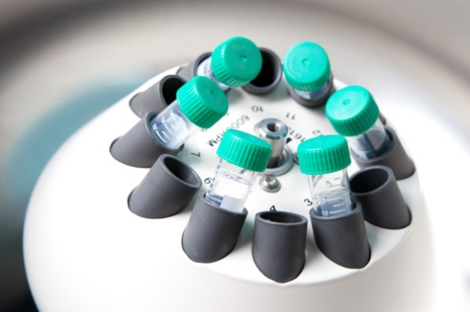Aim

To separate the components tomato sauce.

Materials

• Centrifuge

• Different brands of tomato sauce

• Test tubes

Method

1 Label your test tube with your name and part fill it with tomato sauce.

2 Pass your test tube to the teacher and observe how he or she sets up the centrifuge.

3 Examine the test tubes when the centrifuge completes the separation.

4 Use a ruler to measure the amount of each separated component of tomato sauce.

5 Draw one of the test tubes after centrifuging. Identify and label the parts of the tomato sauce (ie water, tomatoes).

Inquiry: What if different brands of tomato sauce were centrifuged?

1 What type of tomato sauce will you centrifuge?

2 What differences might you expect from the tomato sauce you tried?

3 What variables will you keep the same as in the first method?

Results

1 Centrifuge your tomato sauce. Draw and label the various components of the tomato sauce.

|  |
| --- |
|  |

2 Draw a column graph below to show the type of tomato sauce and the amount of each component.

|  |
| --- |
|  |

Discussion

1 What differences did you notice between the different types of tomato sauce after they had been centrifuged?

2 Can you explain why the different types of tomato sauce might vary in their components?

Experiment worksheet

2.4 Mixtures can be separated according to their size and mass

Pages 36–37 and 179

Skills Lab 2.4: Filtering a mixture of sand and water

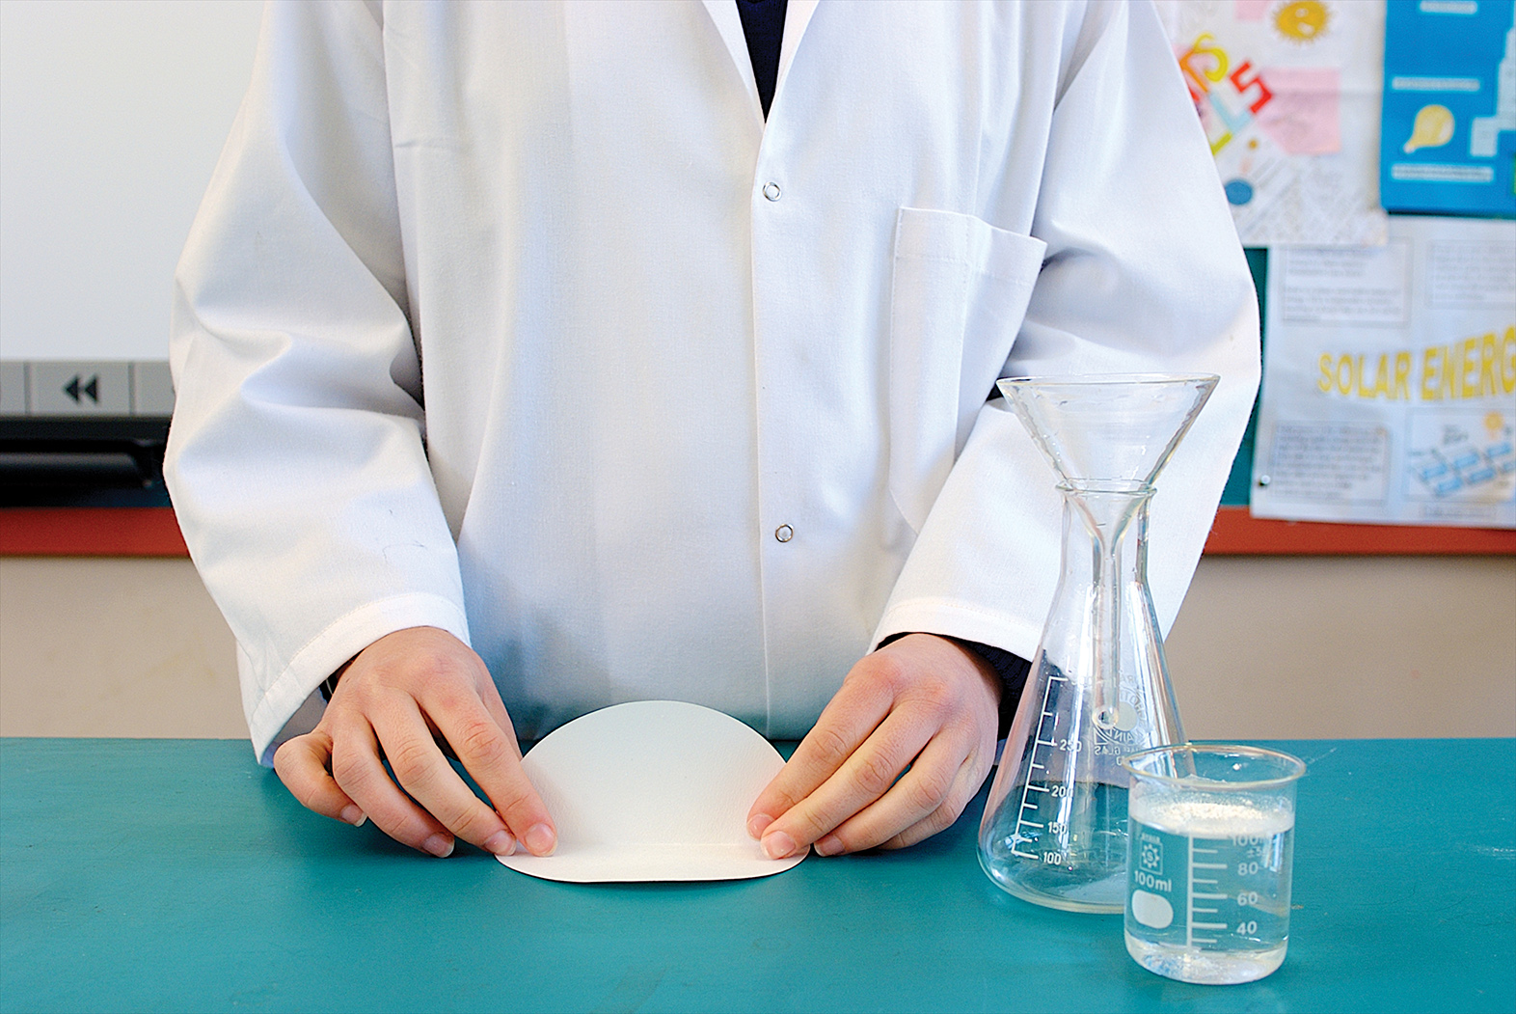

**Figure 1**

What you need:

mixture of sand and water, beaker, 100 mL conical flask, spatula, small funnel, filter paper, stirring rod

What to do:

1 Fold a round filter paper in half, then in half again to get quarters and then in half again to get eighths, as seen in Figure 1.

2 Unfold the filter paper and lay it flat (Figure 2).

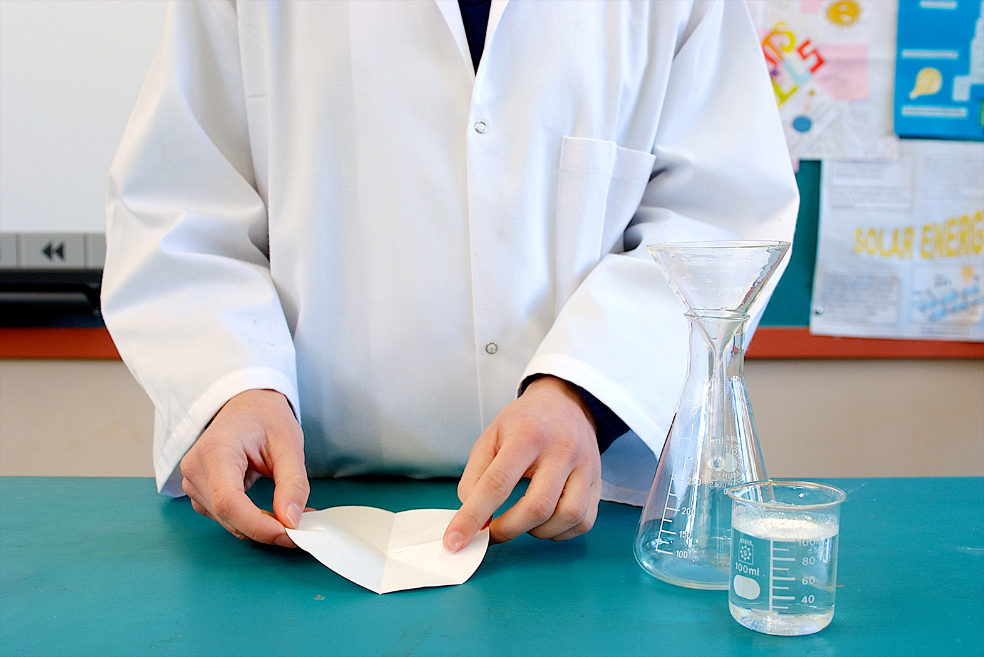

**Figure 2**

3 Re-fold back and forth over the creases in the filter paper to obtain a fluted shape, as shown in Figure 3.

4 Set up the funnel and flask as shown in Figure 4.

5 Place the filter paper into the funnel as shown in Figure 5.

6 Dampen the filter paper with some extra water to help it stick to the sides of the funnel (see Figure 6).

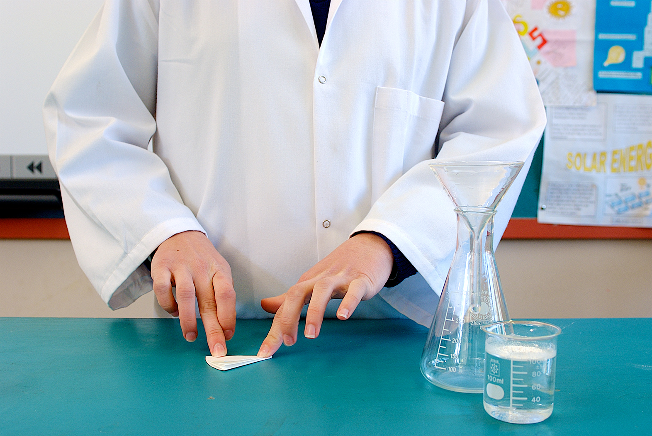

**Figure 3**

7 Swirl the sand mixture and slowly pour it from the beaker into the funnel (Figure 7). Do not overfill the funnel.

8 Keep adding the mixture slowly until it is all used up.

9 Extra water can be added to the beaker mixture to pour out the last solid particles.

10 Wait for the filtering to finish. Remove the filter paper carefully and allow it to dry. In most experiments the residue (the solid on the paper) is kept and the filtrate (the liquid in the flask) is discarded.

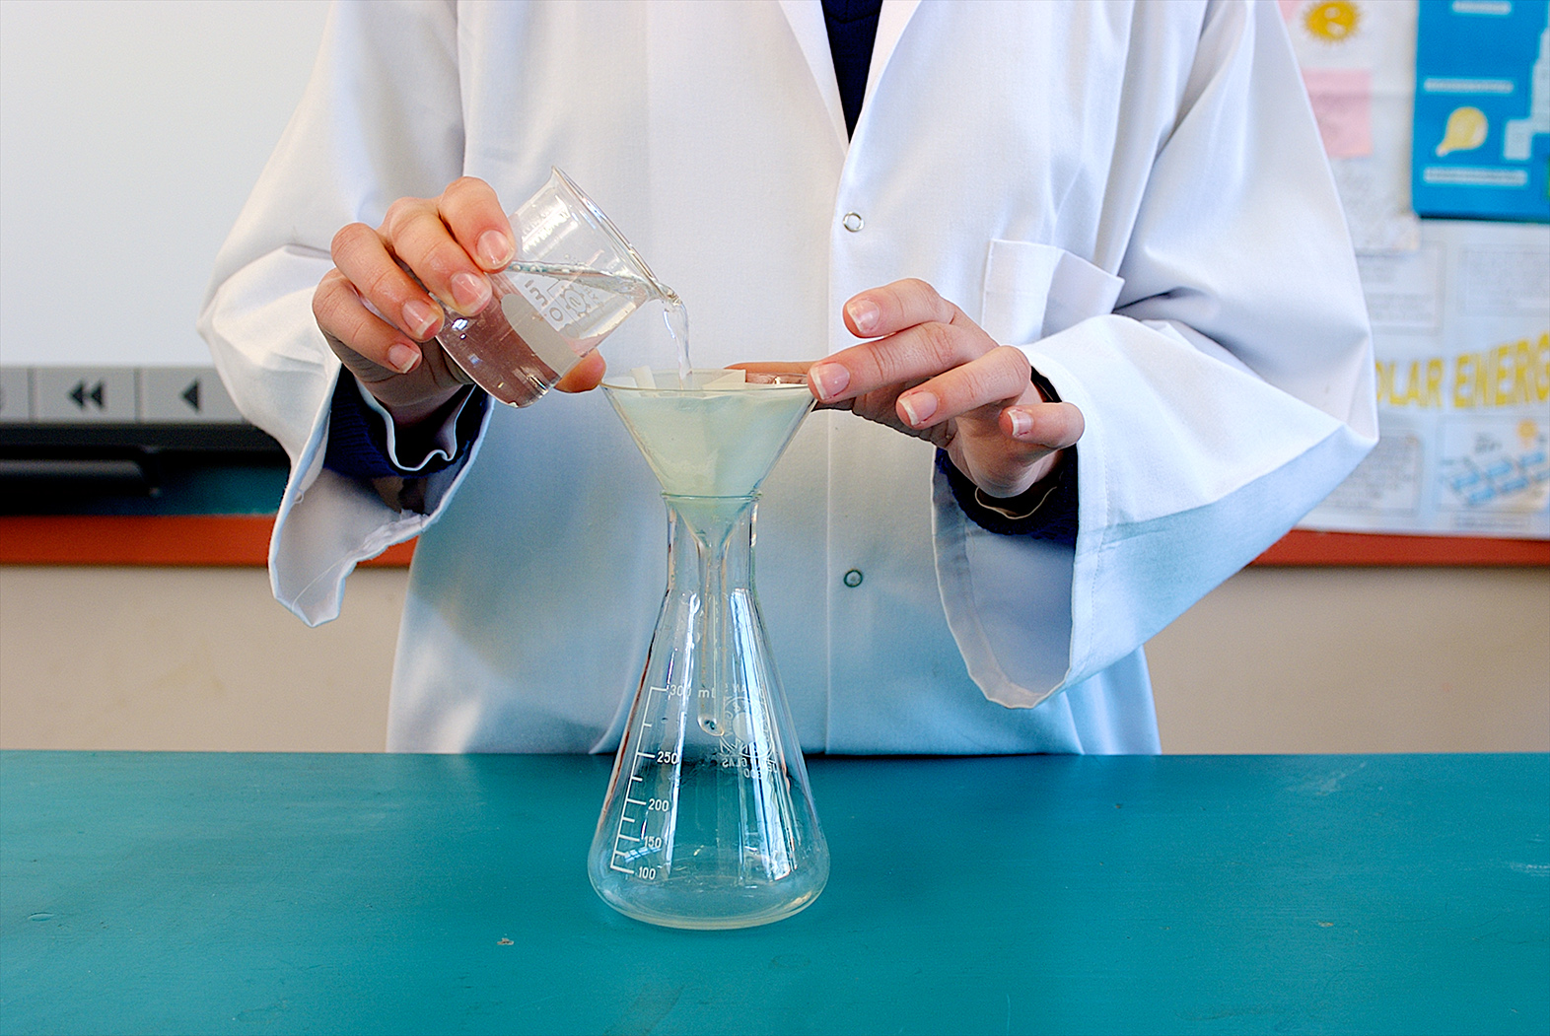

**Figure 7**

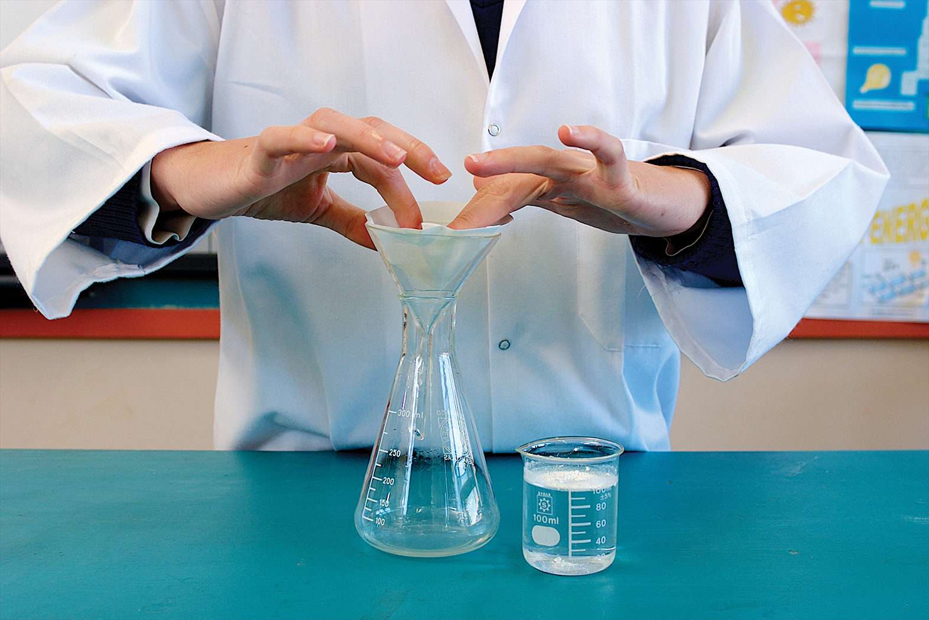

**Figure 6**

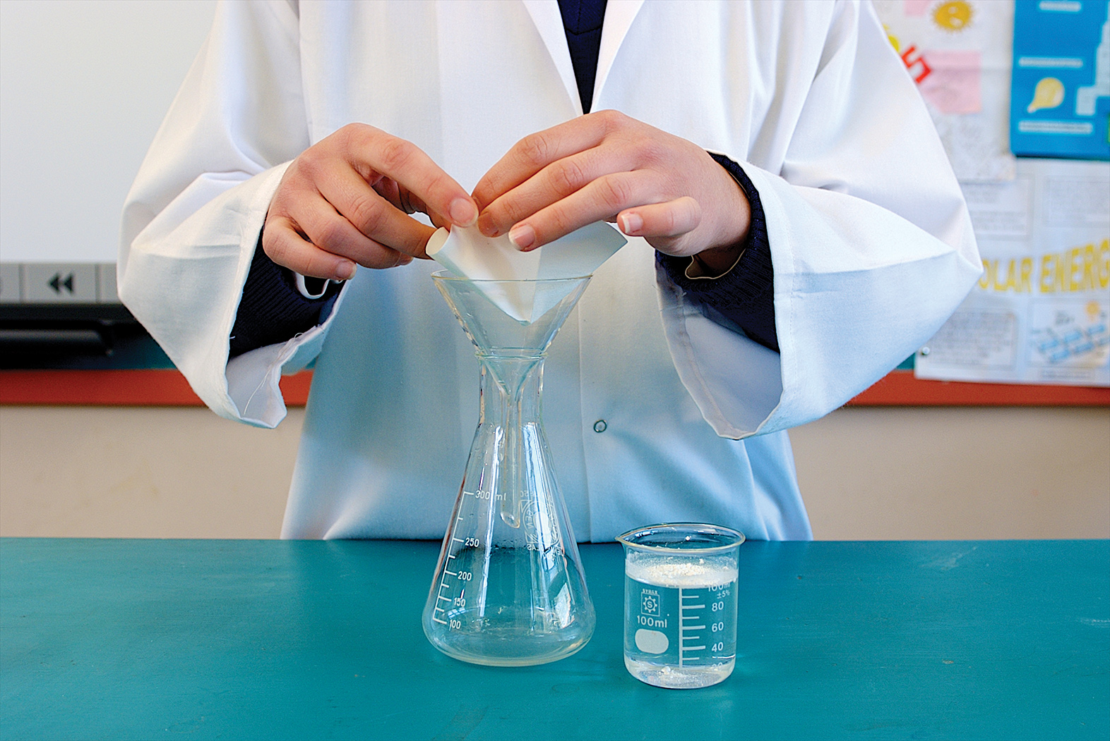

**Figure 5**

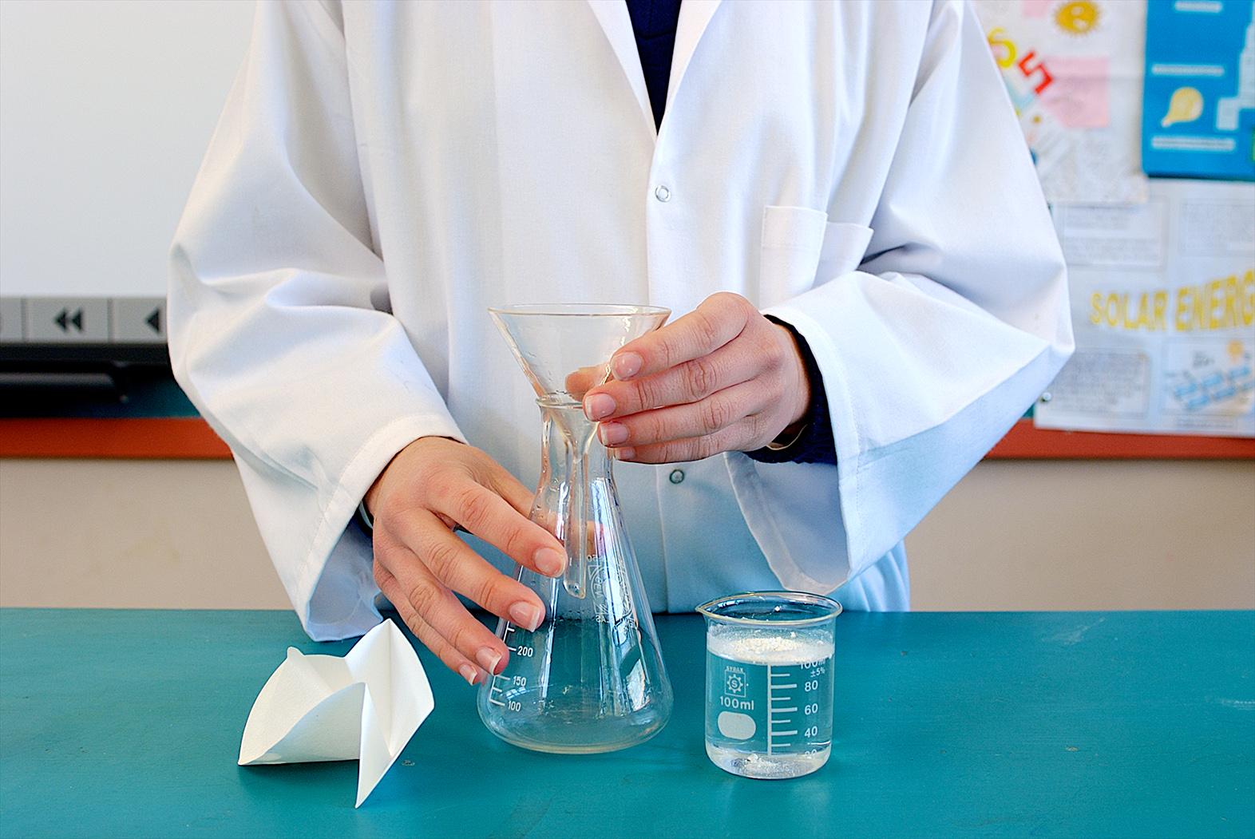

**Figure 4**

Questions

1 Draw a scientific diagram of your equipment. Label the filtrate and residue.

|  |
| --- |
|  |

2 What physical properties are being used to filter substances?

3 Describe at least three things you need to be careful about when filtering.

Experiment worksheet

2.5 The boiling points of liquids can be used to separate mixtures

Pages 38–39 and 180

Experiment 2.5: Crystallisation of salt water

Aim

To separate a salt from a solution by evaporation and crystallisation.

Materials

• Evaporating dish

• Tripod

• Clay triangle

• Bunsen burner and mat

• Salt solution

• 250 mL beaker

• Magnifying glass

• Matches

Method

1 Collect a sample of the salt solution.

2 Half-fill an evaporating dish with the solution.

3 Place the evaporating dish on the clay triangle over the tripod.

4 Heat the evaporating dish, with a blue flame.

5 When the solution starts boiling, half-close the Bunsen burner collar. (Don’t change to a yellow flame – this is not the same.)

6 Add more solution to the dish as the level drops due to evaporation. Be careful as the evaporation nears completion because the hot salt may spit and splatter.

7 Turn off the Bunsen burner when just a little liquid remains with the salt. Leave the dish to cool.

8 Examine the salt crystals with a magnifying glass.

Results

Draw a diagram of the crystals in the space provided.

|  |
| --- |
|  |

Discussion

After the water has evaporated from the solution, salt remains in the evaporating dish.

1 If the solution contained a mixture of more than one solute, would the separation technique used in this experiment be suitable? Explain.

2 What is wasted in this experiment? Can you think of any way this could be avoided?

Conclusion

Explain how evaporation and crystallisation can be used to separate a mixture of salt and water.

Experiment worksheet

2.5 The boiling points of liquids can be used to separate mixtures

Pages 38–39 and 181

Challenge 2.5: Design a way to purify water from sea water

Design brief

You are preparing for a natural disaster that will affect the water supply. Design some equipment that will enable you to provide drinking water for a single person from sea water indefinitely.

Criteria restrictions

• Your materials must be available in a supermarket or your home.

• You must provide the cost of building your equipment.

• Your only available heat source is the Sun.

Questioning and predicting

1 How will you heat the water so that it evaporates?

2 How will you collect the water vapour?

3 How will you cool the steam so that it condenses?

4 Draw a labelled diagram of your design.

|  |
| --- |
|  |

5 Build a prototype of your design.

Processing, analysing and evaluating

1 What changes did you have to make to improve your design?

2 What was the most successful feature of your design? What was the least successful?

3 What was the final cost of your design?

4 Is there any practical use for your design?

5 If you were doing this experiment again, how would you modify your design? Explain.

Communicating

Present the various stages of your investigation in a formal experimental report.

Experiment worksheet

2.6 Solubility can be used to separate mixtures

Pages 40–41 and 182

Experiment 2.6: Who wrote the nasty note?

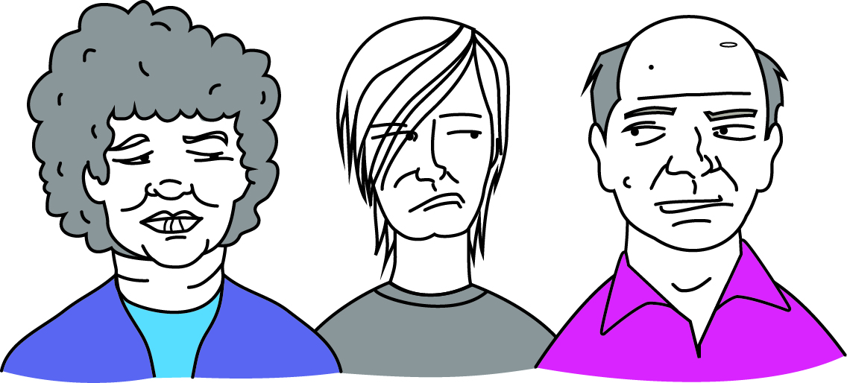Your forensic laboratory is investigating a crime of extortion: one person is forcing or frightening another into handing over money. The police have identified that the extortion note was written with a black felt-tip pen. They have collected a black felt-tip pen from the three suspects: Aunt Aggie (A), Cousin Cranky (C) and Uncle Buncle (U).

Other forensic scientists in your laboratory have already run a chromatography test on the note written by the extortionist. After you have tested the three pens from the suspects, collect the chromatogram from the original note from your teacher for comparison.

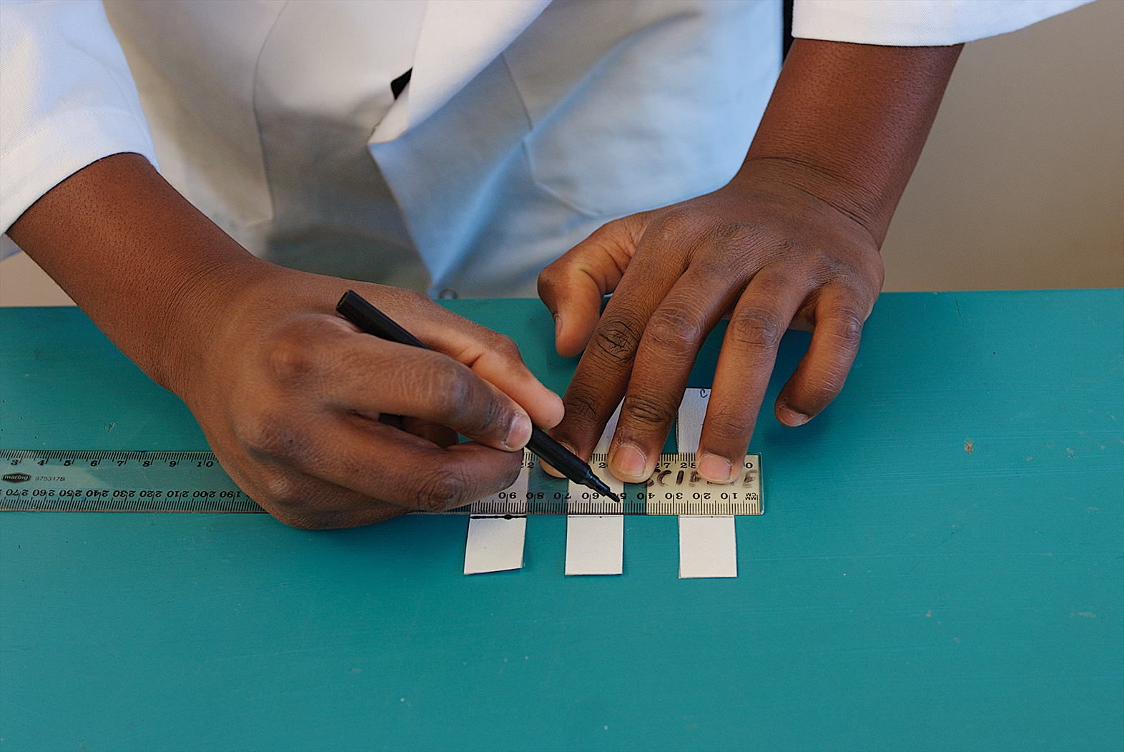

**Figure 1**

Aim

To separate the inks from three different water-soluble black felt-tip pens.

Materials

• 3 black watersoluble felt-tip pens (they must all be different brands and labelled A, C and U) (Note: Permanent markers are not suitable for this experiment because they are not watersoluble.)

• 250 mL beaker

• Glass rod

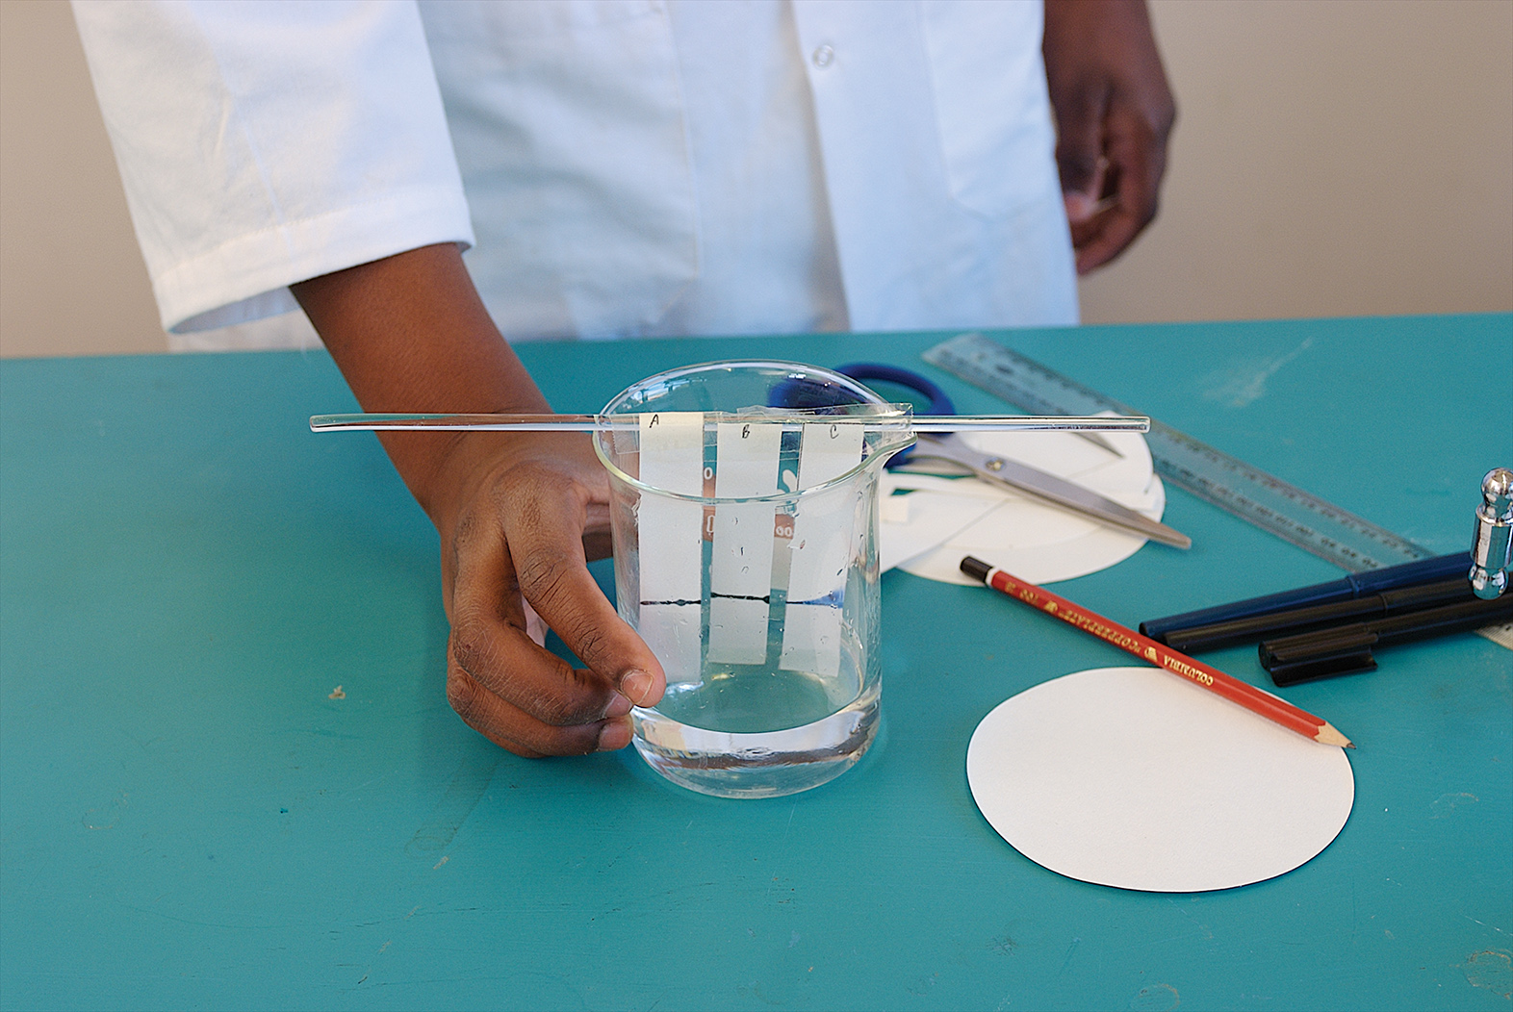

**Figure 2**

• Salt solution (1%)

• Filter paper or chromatography paper

• Scissors

• Pencil

• Ruler

Method

1 Cut the filter or chromatography paper into three strips measuring approximately 2 cm × 10 cm.

2 Draw a faint pencil line across the width of each paper strip, 3 cm from the bottom.

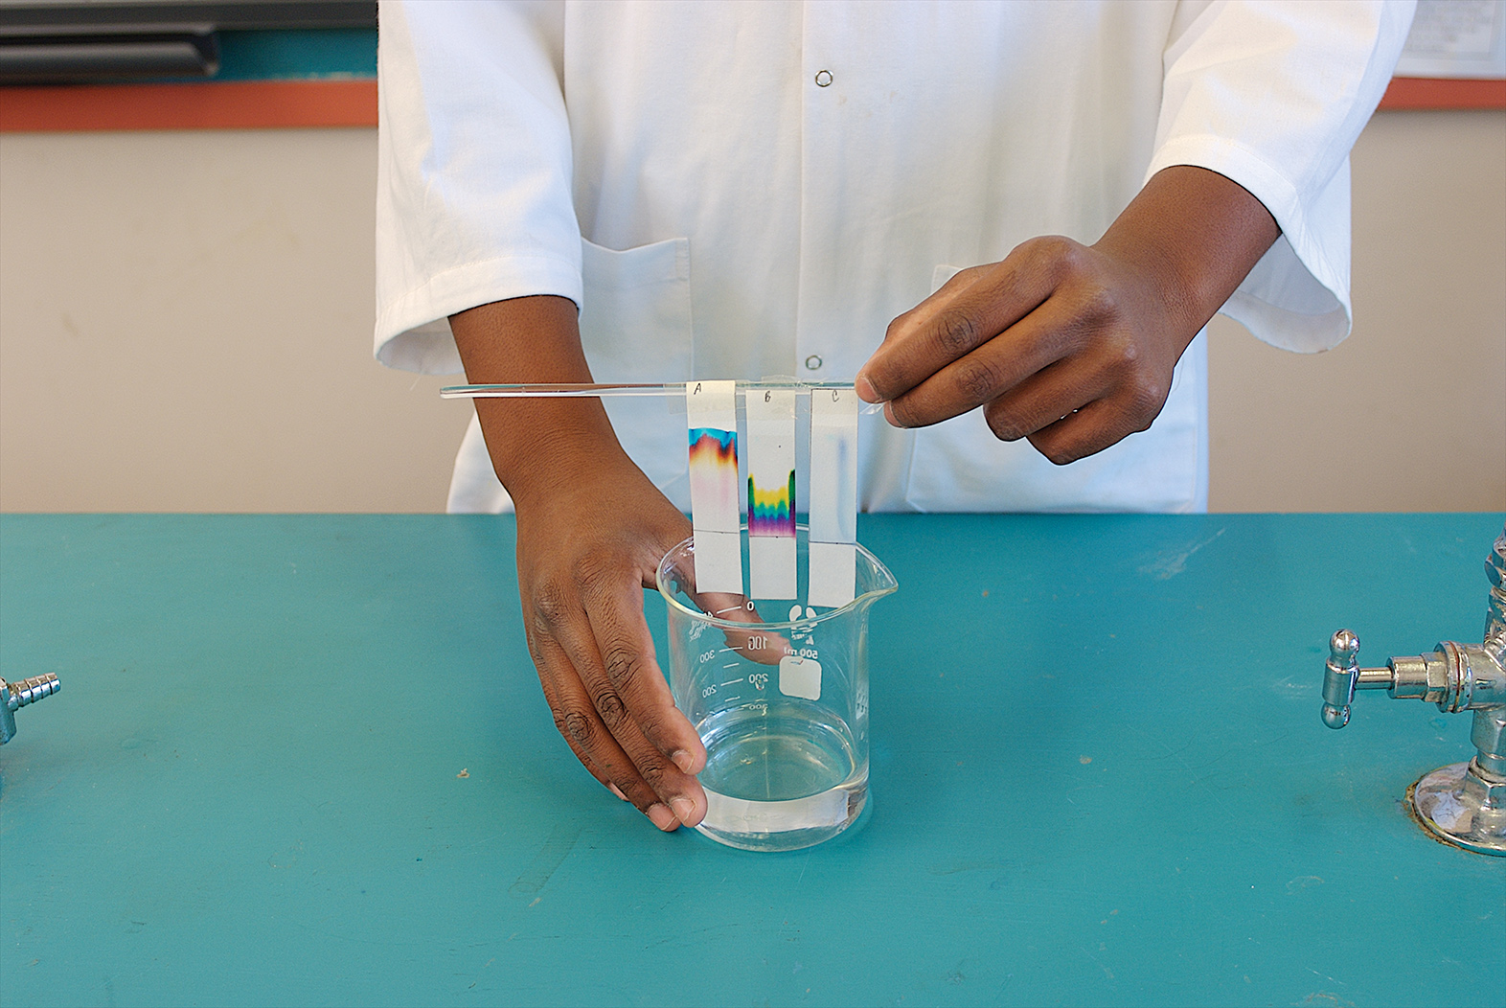

**Figure 3**

3 Label one strip A, another C and the remaining one U. Make sure the label is at the very top of the paper strip.

4 Carefully trace over the pencil line at the bottom of strip A with the first felt-tip pen. (Do not make the line too thick.)

5 Do the same for the other two pens on their separate strips.

6 Add the salt solution to the bottom of the beaker, no deeper than approximately 2 cm.

7 Hang the paper strips over the glass rod so that they just dip into the salt solution as shown in Figure 2. Make sure the salt solution does not touch the pen lines on the paper.

8 Leave the papers to soak up the salt solution for approximately 10–15 minutes, or until the solvent level is up to the top of the paper.

9 In the meantime, draw a diagram of the chromatography equipment in your notebook, labelling all the parts.

10 When the chromatogram is finished, take the papers out of the solution to dry as shown in Figure 3.

Results

Tape the dry chromatograms for suspects A, C and U in your notebook or workbook. Collect and copy the chromatogram from the original note. Label this as the extortionist’s chromatogram.

Discussion

1 Compare the chromatogram for the extortionist with the chromatograms from the three suspects. Do any of the suspects’ chromatograms match the one from the original note? If so, who is most likely to be guilty?

2 Which felt-tip pen (A, C or U) had the most colours in its black ink?

Conclusion

How can the inks from three different black felt-tip pens be separated?

Experiment worksheet

2.6 Solubility can be used to separate mixtures

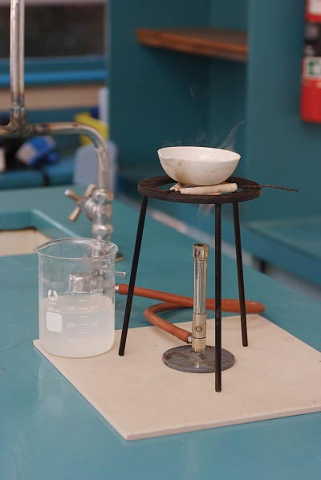Pages 40–41 and 183

Challenge 2.6: Separation challenge

Challenge

Now that you are a scientist who has trained in separating techniques, it is time to separate a mixture of sand, salt, sawdust and iron filings.

Criteria restrictions

You may only use equipment available in the laboratory.

Questioning and predicting

Think about the properties of each pure substance. This may help you decide on a way to separate the substances. Write what you know about the properties of sand, iron filings, sawdust and salt in the table below.

|  |  |  |  |
| --- | --- | --- | --- |
| Substance | Soluble in water? | Attracted to a magnet? | Floats/sinks in water? |
| Sand |  |  |  |
| Iron fillings |  |  |  |
| Sawdust |  |  |  |
| Salt |  |  |  |

Discuss with a partner some possible ways to separate the four substances.

Planning and conducting

1 Draw up a flow chart showing the steps you will take to separate the four substances.

|  |
| --- |
|  |

2 Devise an aim and an equipment list for your experiment.

3 Write a detailed method for separating the substances. Include at least two diagrams.

|  |  |
| --- | --- |
| Diagram 1: | Diagram 2: |

4 What safety issues might there be when doing this experiment?

5 Have your plan checked by your teacher.

6 Perform your separation experiments and make relevant observations.

Processing, analysing and evaluating

1 How well did your plan work? Grade the success of the plan on a scale of 1–5, where 1 means the experiment did not work well and 5 means the experiment was a great success. If you completed this challenge as a group, discuss your grading with others in your team. Build a prototype of your design.

2 If your success was lower than 5 on the scale, how would you change ‘plan B’ to improve the results on another occasion?

3 Did you manage to separate the four substances successfully? Write your answer to this question as the conclusion in your laboratory report.

Communicating

Present your investigation in a formal experimental report.